Write a query to get unique department ID from employee table

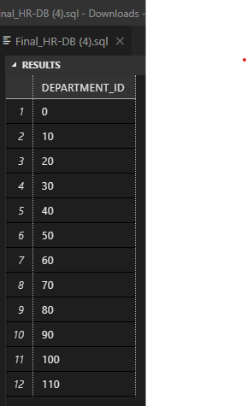

select distinct(DEPARTMENT_ID) from employees;

Write a query to get all employee details from the employee table order by first name, descending.

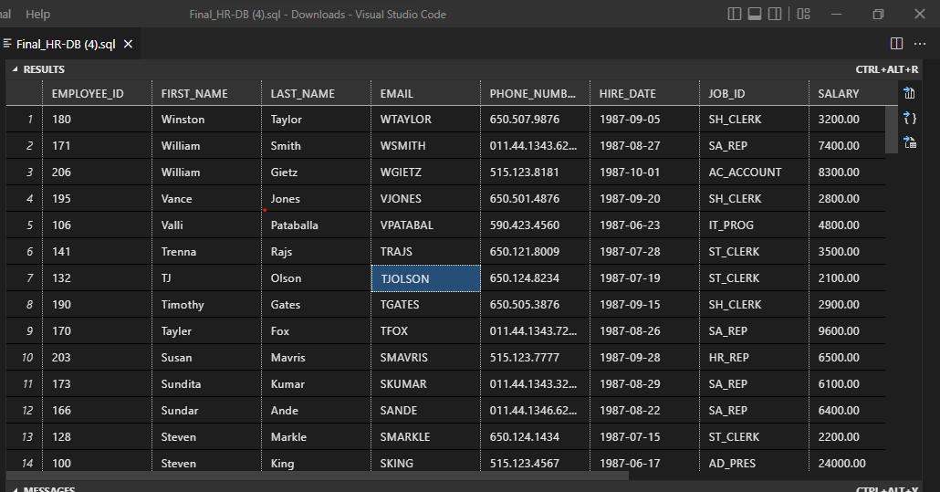

select * from employees ORDER By FIRST_NAME DESC;

Write a query to get the employee ID, names (first_name, last_name), salary in ascending order of salary

SELECT EMPLOYEE_ID, FIRST_NAME, LAST_NAME, SALARY FROM employees order by SALARY ASC;

Display first name and join date of the employees who is either IT Programmer or Sales Man

SELECT FIRST_NAME, HIRE_DATE, JOB_ID FROM employees where JOB_ID = 'IT_PROG' OR JOB_ID = 'SA_MAN';

Display details of employee with ID 150 or 160.

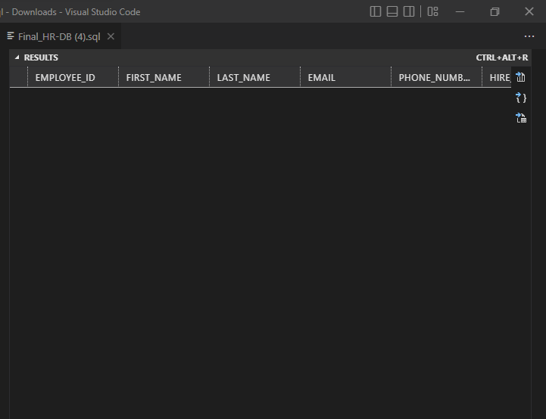

SELECT * FROM employees where DEPARTMENT_ID = 150 OR DEPARTMENT_ID = 160;

Display first name, salary, commission pct, and hire date for employees with salary less than 10000.

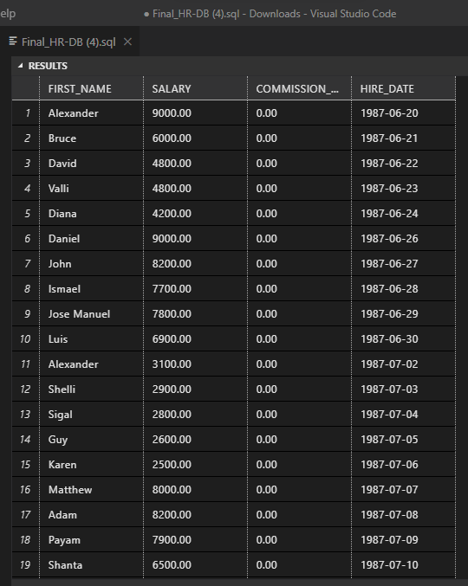

SELECT FIRST_NAME, SALARY, COMMISSION_PCT, HIRE_DATE FROM employees where SALARY < 10000;

Display employees where the first name or last name starts with S.

SELECT FIRST_NAME, LAST_NAME FROM employees WHERE FIRST_NAME LIKE 'S%' OR LAST_NAME LIKE '%S';

Display details of jobs in the descending order of the title.

select * from jobs order by JOB_TITLE DESC;

Display details of the employees where commission percentage is null and salary in the range 5000  
to 10000 and department is 30

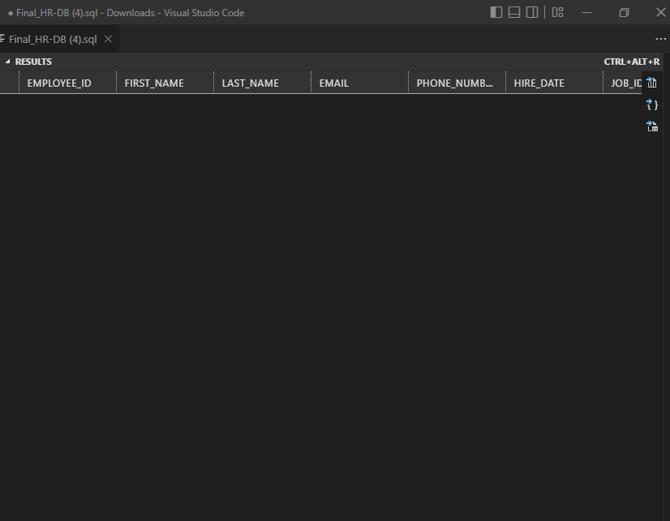

select * from employees where COMMISSION_PCT = 0 AND (SALARY BETWEEN 5000 AND 10000) AND DEPARTMENT_ID = 30;

Display employees first_name,email who are working in “Executive” department.

SELECT e.FIRST_NAME, e.EMAIL, e.DEPARTMENT_ID, d.DEPARTMENT_ID, d.DEPARTMENT_NAME as Basic_Info FROM employees e full outer join departments d on e.DEPARTMENT_ID=d.DEPARTMENT_ID WHERE DEPARTMENT_NAME = 'Executive';

Display unique contry_id from locations table

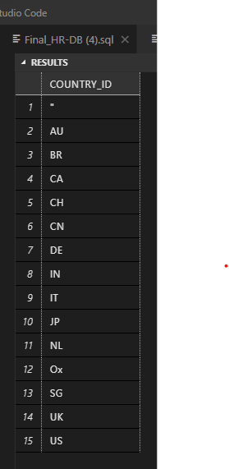

select distinct(COUNTRY_ID) FROM locations;

Display all employees whose have job_id IT_PROG and FI_ACCOUNT.

select * from employees where JOB_ID = 'IT_PROG' OR JOB_ID = 'FI_ACCOUNT';

Display all countries in ascending order.

SELECT COUNTRY_NAME FROM countries ORDER BY COUNTRY_NAME ASC;